
MM570 Applied Statistics for Psychology
Unit 9 Project: Descriptive Statistics
This is a course level assessment assignment. MM570-3: Interpret correctly the output from SPSS analyses/statistical tests.
Your Name:

HINTS AND HELP
Dataset: Stat_Grades.sav can be found in Doc Sharing under the Instructor Graded Projects category.

Note: When asked to include the interpretation of the results and final conclusions, be sure to include all results, an interpretation of the meaning of the results, and final conclusions that a common person can understand. Make sure you use complete sentences, paragraph form (single spacing), proper grammar, and correct spelling. Minimal or incomplete responses can lose points. Include any SPSS results that you use, but do not include SPSS results that are not part of your solution.

Hint: You are asked to determine “appropriate” tests and methods, and to make calculations. This means that you will have to determine which tests or methods are best and why.

Remember to always show all of your work and each of your steps.
For each question, follow the appropriate steps.
1) Write the hypothesis - Construct the null(s) and alternative(s) clearly and appropriately.
3) Run the appropriate SPSS test(s) and include the appropriate results
4) Explain and evaluate the SPSS results
5) Write a complete and paragraph form conclusion that can be understood by a normal non-statistical person.

Use the Live Binder for further assistance. There is a link to the Live Binder under every Unit.

Point Possible | Grading Criteria
A: 153 - 170 points | Student work demonstrates mastery of the objectives assessed by the Assignment. This is evidenced by at least the following:  · The selection of the statistical procedure(s) is/are the most appropriate ones for answering the questions; specifically, the correct ANOVA test method is selected for each question.  · The statistical procedure was calculated correctly using SPSS.  · The interpretation of the SPSS output is correct and complete, including applying the (Sig. in SPSS) p-value to determine null hypothesis rejection.  · The results of the statistical analyses are presented in easy to understand, non-statistical language that addresses the research question.  · SPSS output that is not needed in the solution is not included. Only appropriate SPSS output are included.  · Each step of the hypothesis testing procedure is included and Ho and Ha are clearly written.  · All aspects of the tests are included and explained, including the Post Hoc results and the interaction plot.  · Appropriate regression prediction equations are created and evaluated.

Use alpha = .05 for this project.

1. Compare the different Ethnicities of students in the Stat_Grades.sav dataset to determine if there is a statistically significant difference in the average Final Exam Points between the different ethnic groups. Be sure to state the hypothesis, state Ho and Ha, include and explain all SPSS results, and write final conclusions for the full results of the test. Include Post Hoc results and the plot. Be sure that your final conclusions are written in common terms for an average person to understand.
(a) What is the hypothesis being tested?

(b) What are Ho and Ha?

(c) What statistical test will you run - and include all the SPSS outputs (including the plot and post hoc)?

(d) Explain the full results for the statistical test that you ran above. Was a post hoc actually needed in this case? Why or why not? Does the Post Hoc confirm your results, explain? What does the plot tell you about the interaction, explain?

(e) Write a full conclusion for all results on this test in a way that can be understood by a non-statistical person. This answer will be at least 100 words or more.

2. Extend the hypothesis from number one above. Compare the different ethnicities of the students in the Stat_Grades.sav dataset and the genders to determine if there is a statistically significant difference in the average Final Exam Points between the different ethnicities and different genders. Be sure to state the hypothesis, state all Ho and Ha, include and explain all SPSS results, and write final conclusions for the full results of the test. Include Post Hoc results, note any interactions and whether they are significant, and include and explain the plot. Be sure that your final conclusions are written in common terms for an average person to understand.

(a) What is the hypothesis being tested?

(b) What are the set of Ho’s and Ha’s?

(c) What statistical test will you run - and include all the SPSS outputs (including the plot and post hoc)?

(d) Explain the full results of the statistical test you have run. Was a post hoc actually needed in this case? Why or why not? Does the Post Hoc confirm your test results, explain? What does the plot tell you about the interaction, explain?

(e) Write a full conclusion for all results on this test in a way that can be understood by a non-statistical person. This answer will be at least 100 words or more.

3. Prediction and Regression. If you recall from the Unit 3 Project, you looked at how to measure the relationship (correlation) between any two variables. You also learned that if two variables are strongly correlated (related) with each other, that one variable can be used to estimate or predict the other. The equation used to make this prediction is called a regression equation.

Use the following SPSS outputs to answer the questions. The two variables in this case are Final Exam Points and Total Points.

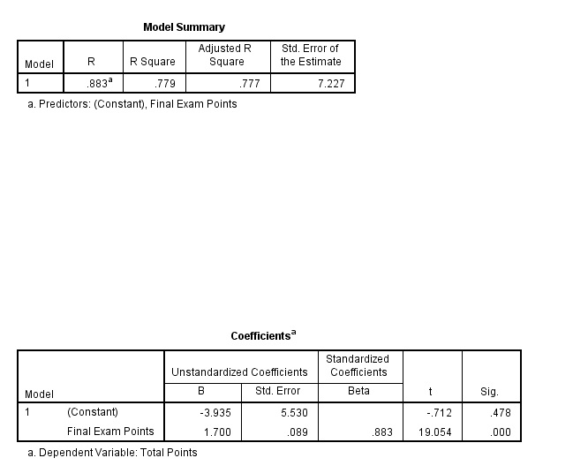

(a) What are the two variables that this question is investigating? Notice that the SPSS output above tells you that the r-value (called “R”) is .883. Is this r-value strong enough to allow you to perform prediction between these two variables? Explain.

(b) Using the “Coefficients” SPSS output above, create the prediction equation. Remember that your independent or “x” variable is Final Exam Points and your dependent or “y” variable is Total Points. Write the prediction equation here.

(c) Using the prediction equation that you created in part (b), predict the Total Points for a student with a Final Exam Points value of 61. Show all work.

4. From the Stat_Grades.sav dataset, use Quiz 1 and Quiz 5 to answer these questions. The question you will be considering here as you answer the questions below is “Is the score on Quiz 1 highly correlated to the score on Quiz 5 and can one be used to estimate or predict the other?”

(a) What is the correlation or relationship (r-value) between Quiz 1 and Quiz 5? Is it weak, medium, or strong? Is it strong enough to use for prediction?

(b) Use SPSS and run a regression analysis on Quiz 1 and Quiz 5. Place the SPSS “Coefficients” output (only) here.

(c) Use the SPSS output to create the regression (prediction) equation. Remember, you are trying to predict how a student will perform on Quiz 5 based on how they do on Quiz 1. What is your dependent (y) variable? What is your independent (x) variable? Write the prediction equation here.

(d) Use your prediction equation to predict how a student would perform on Quiz 5 if they got a 7 on Quiz 1. Show all work.

Submitting your Project

Make sure your name is on your project and saved to your computer. When you are ready to submit your completed project, click on the Dropbox and complete the steps below:

• Click the link that says “Submit an Assignment.”
• In the “Submit to Basket” menu, select Unit 9: Project.
• In the “Comments” field, include your name and Unit 9 Project.
• Click the “Add Attachments” button.
• Follow the steps listed to attach your Word document.
• You should revisit the Dropbox to view any helpful feedback your instructor has left for you.
• Make sure that you save a copy of your submitted and returned assignment.

